Lab report 4: 2024/04/11

Pooya Nasiri

* In the first task I learned to use opencv canny edge detector and adjust its threshold parameters using trackbars.

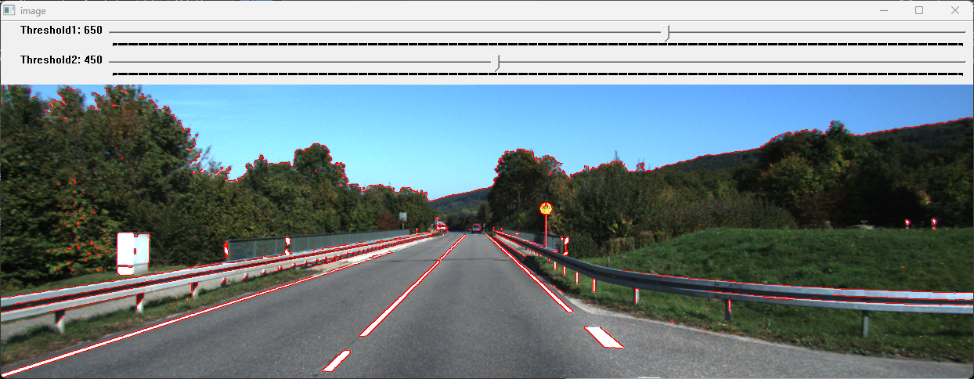

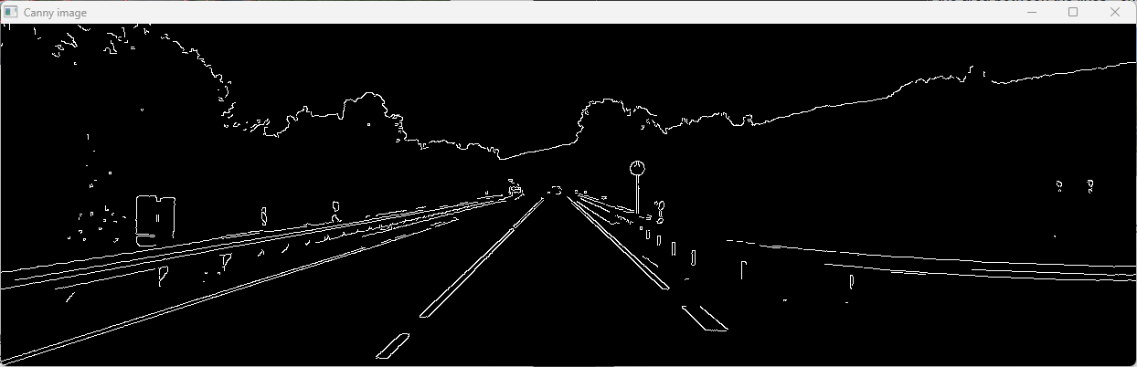

* In the second task I learned how to use color ranges and detect the white markings on the road.

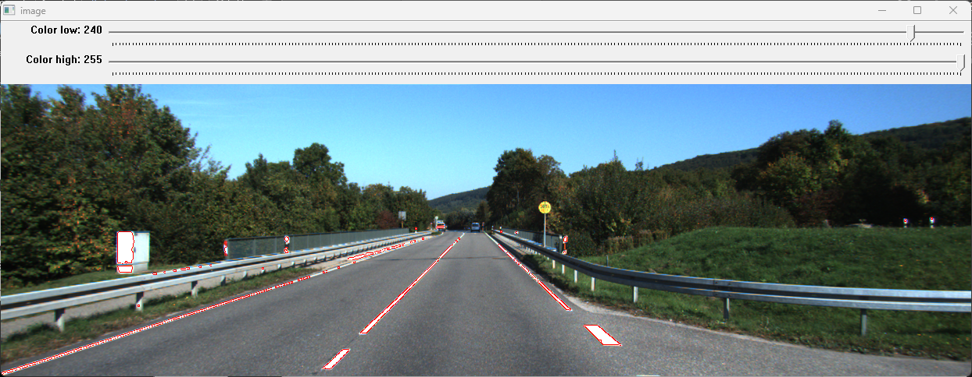

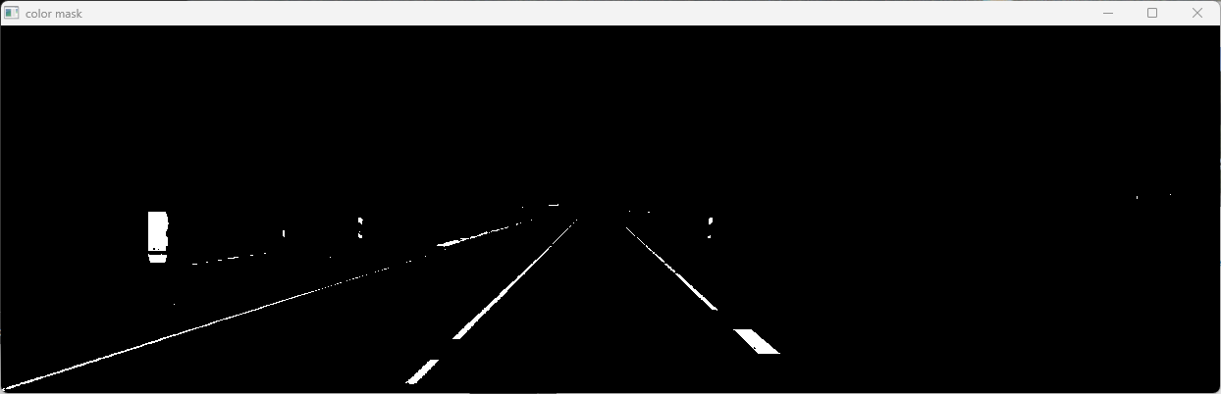

* In the third task I expanded the second task, and used the color mask and canny and HoughLines method to detect all white lines in the image, then using line orientation I could select the two white lines of the road [(~(90-45) and ~(90+45)]. And finally fill the triangle between two lines and bottom of the image as the Road.

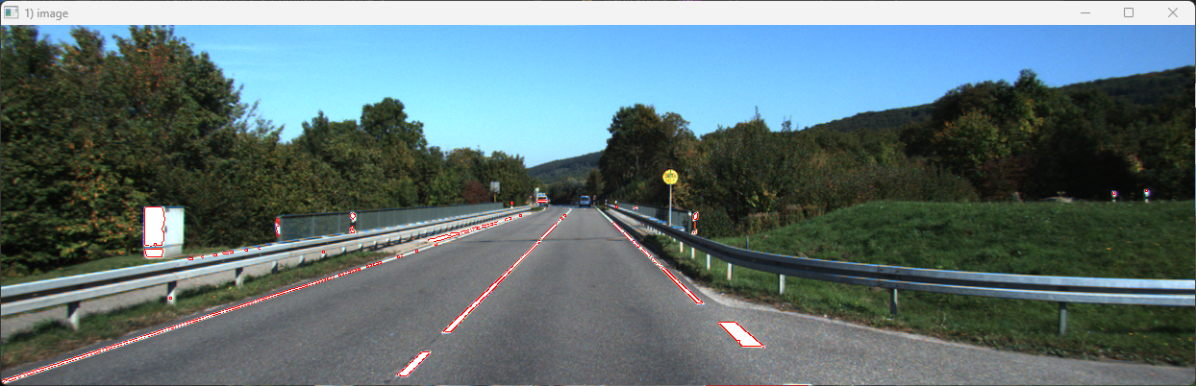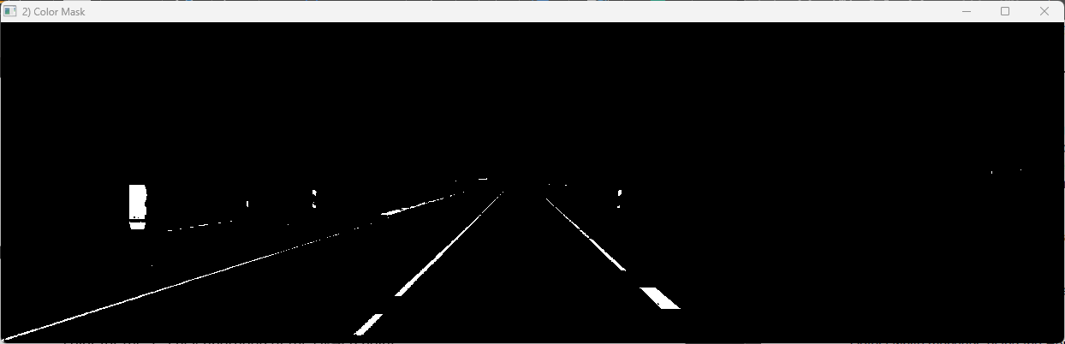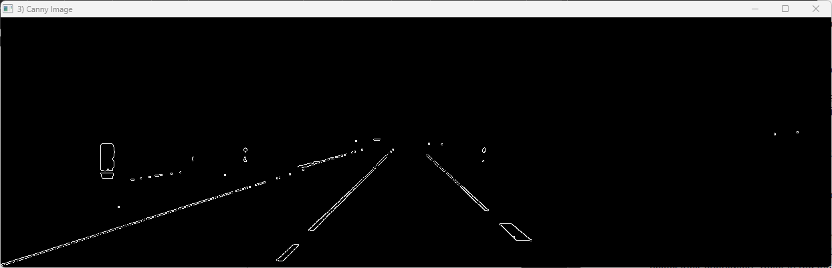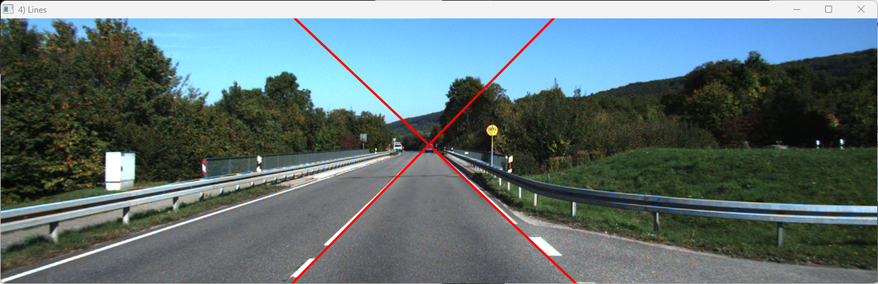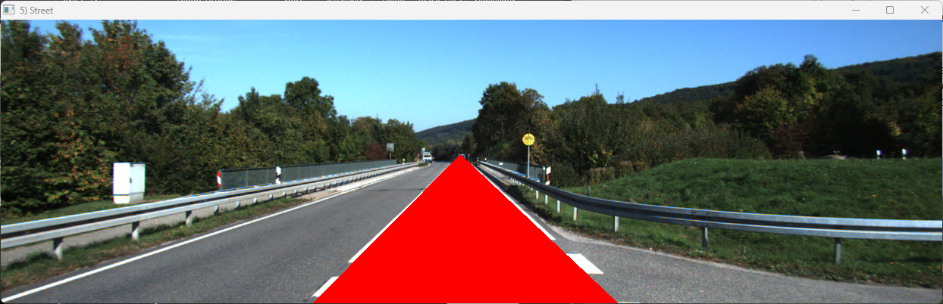

* In the fourth task I learned to use color mask again but this time on the Yellow pixels. And send the result image to HoughCircles() to detect the road sign circle. It was really hard to adjust the parameters correctly for Hough methods.

